**XL Custom Loyalty Label™**

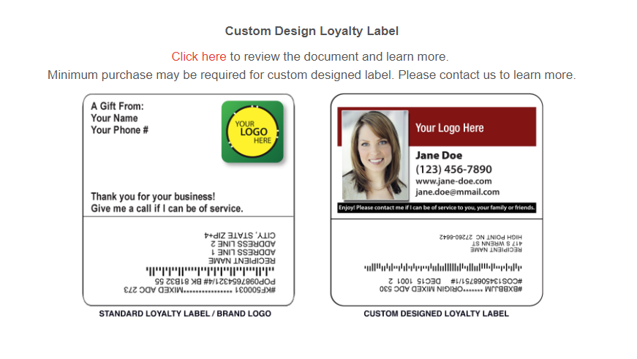

Please choose from 2 options below.

**OPTION 1**

(Custom Loyalty with a purchase of 20 prepay codes, read more about pricing on page 2)

XL Custom Loyalty Label will be designed to your specifications with the purchase of 20 prepay codes at $18 each. Each code is redeemable for a personalized subscription (any magazine in the program, includes multiple issues + announcement postcard). You don’t have to use all 20 codes at one time, you use them as you go.

Submit the following files by emailing at [dawson@ctwo.net](mailto:dawson@ctwo.net):

1. Your company logo (High Resolution File, 250 KB or greater, JPEG or EPS) – please attach to email.
2. You picture (High Resolution File) – please attach to email.
3. Completed form – this form or copy (verbiage) by email.

Edit copy in a yellow highlighter:

|  |
| --- |
| XXXXXXXXXXXXXXXXXXXXXXXXXX  XXXXXXXXXXXXXXXXXXXXXXXXXX  XXXXXXXXXXXXXXXXXXXXXXXXXX  XXXXXXXXXXXXXXXXXXXXXXXXXX  XXXXXXXXXXXXXXXXXXXXXXXXXX |

|  |
| --- |
| Enjoy! Please contact me if I can be of service to you, your family or friends. |

**OPTION 2**

(Custom Loyalty, no minimum purchase)

Please submit the ready file using the specifications below. We will post your file as provided at your magazine account.

Size: 3.75” wide X 2” high

Resolution: 300 dpi

Color Mode: RGB

Saved as EPS, PDF, TIF, JPEG

**SAMPLE:**

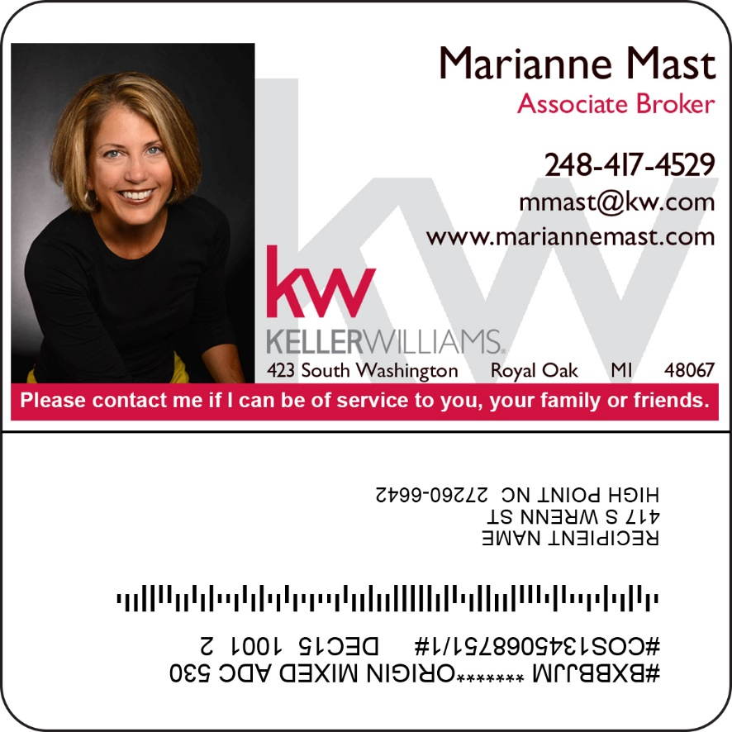

Please note, you get the best price of $18 by purchasing 20 prepay codes at “Order Prepay Codes”, and you automatically qualify for a Custom Loyalty Label at no additional cost. Learn more at Prepay & Save <https://www.magazinegiftprogram.com/Index#prepaid>

